**Objectives**

In this hands-on lab, you will learn how to construct a branch, do some changes in the branch, and merge it with master (or trunk)

**Step 1 - Branching**

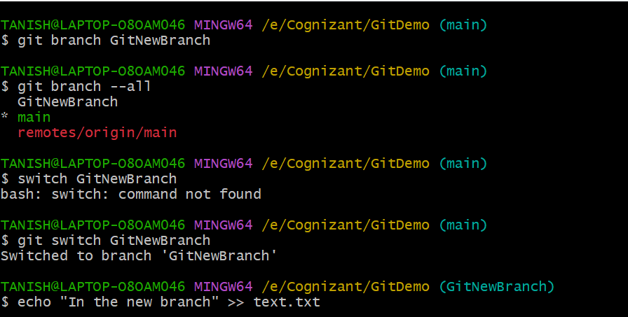

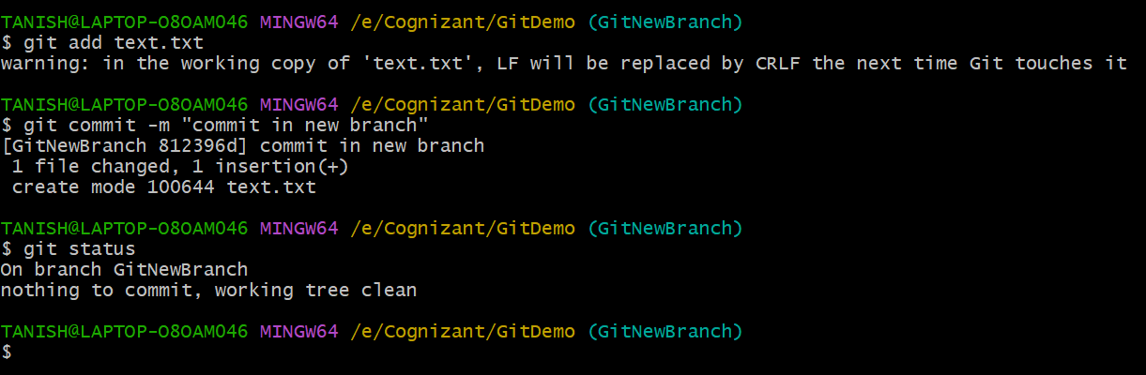

**Step 2 –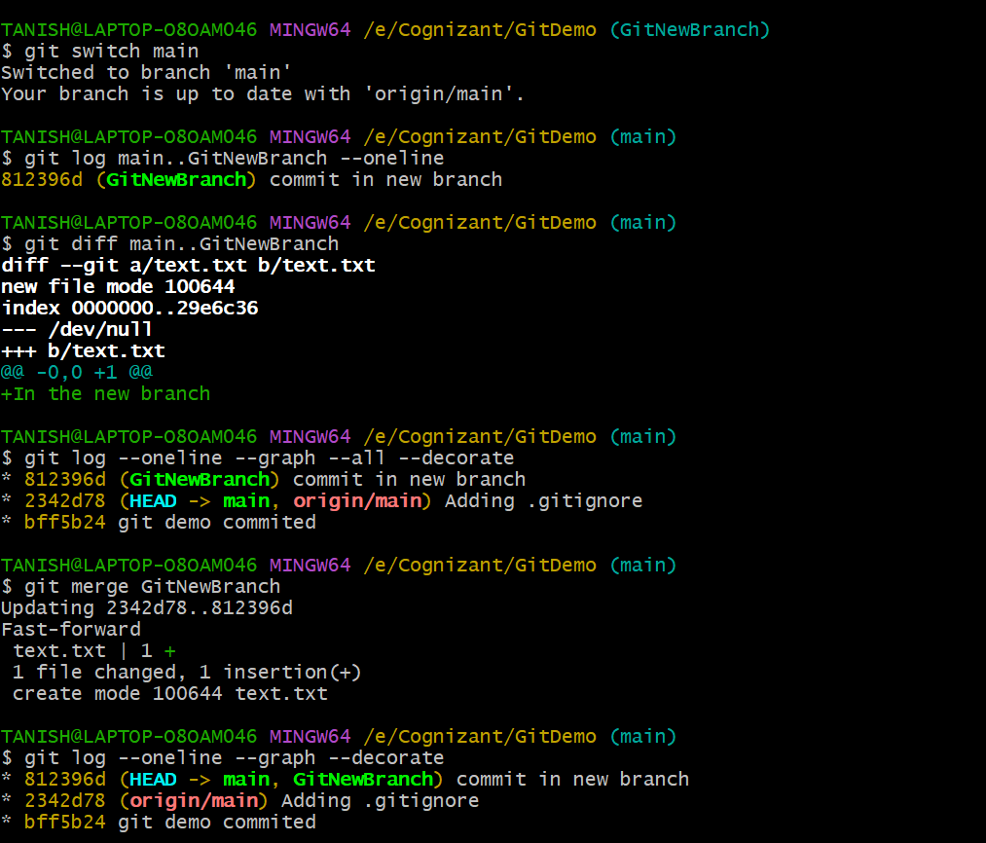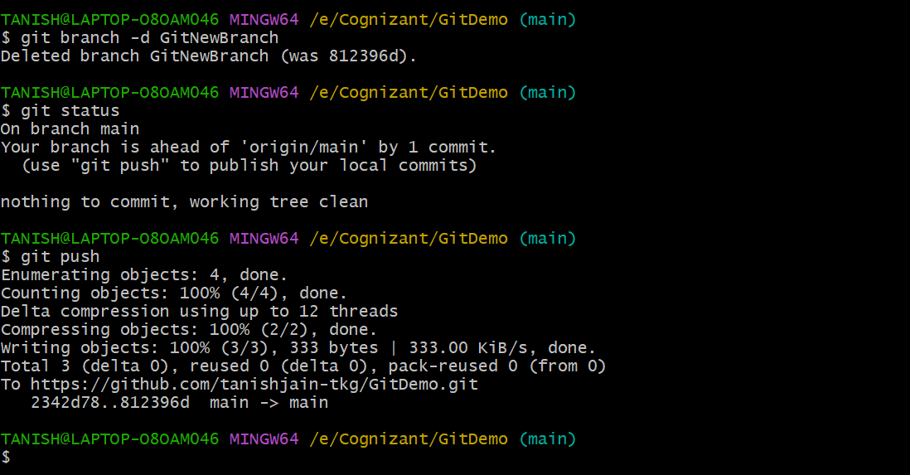 Merging**